Types of Clearing Houses
# Source: AI Source: Provided by: [Data Path: Persons Table -> ID Column: 1, Name_En Column: Motasem Essam] -> From: [ChatGPT] on [1/21/2026]
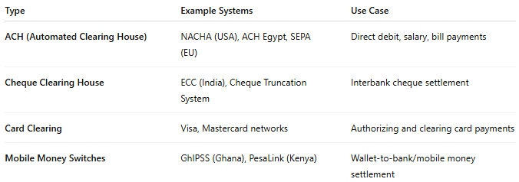

Type | Example Systems | Use Case
ACH (Automated Clearing House) | NACHA (USA), ACH Egypt, SEPA (EU) | Direct debit, salary, bill payments
Cheque Clearing House | ECC (India), Cheque Truncation System | Interbank cheque settlement
Card Clearing | Visa, Mastercard networks | Authorizing and clearing card payments
Mobile Money Switches | GhIPSS (Ghana), PesaLink (Kenya) | Wallet-to-bank/mobile money settlement

